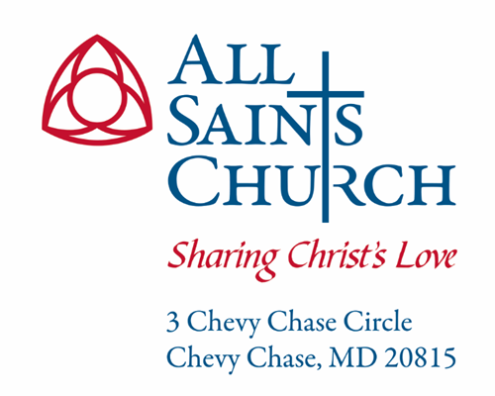

Vestry Meeting Minutes
November 18, 2023

ATTENDANCE
x | Kevin Wrege-‘26  Senior Warden | x | Carrie Clark Carlson – ‘24 | x | Rev. BJ Buracker  Vicar
x | Dan Buckingham-‘26  Junior Warden | x | Liza Cole – ‘25 | x | Rev. Matthew Kozlowski  SeniorAssociate Rector
x | Michael Petrucelli – ‘24 | x | Catherine Eshelman – ‘25  Secretary | x | Lois McDonald  Chief of Staff
x | Mark Pelesh – ‘24  Treasurer | x | Susan Awad-‘24 | x | Teri Ballou  Communications Director
x | Beryl Scott-‘26 | x | Robert Roop – ‘25 | x | Rev. Jamie Pahl  Rector
 | Hugh Webster-‘26  Assistant Treasurer |  | Nick Thompson  Prager Metis
x | Jennifer Sirangelo-‘25 |  | Rev. Zacher Bayonne  Deacon
An x denotes that the individual was present, while an empty box denotes absence.

EXECUTIVE SUMMARY / ACTIONS AT A GLANCE
- A quorum was present  - Review and approval of minutes  - Treasurer’s report  - Rector’s report | - Reports from Clergy in attendance  - Old and new business  - Closing prayer and adjournment

DETAILS OF THE MEETING

Opening Father Jamie Pahl
Following the Vestry retreat, a quorum being present, Father Jamie called the meeting to order at 1:50 pm.

Presentation of Minutes Catherine Eshelman
The minutes of the October 24 Vestry meeting were presented for approval. Drafts of the minutes, as well as the attachments referenced within the minutes, were circulated in advance of the meeting. After a motion duly made and seconded, the members of the Vestry voted to approve the following:

RESOLVED: That the minutes of the October 24, 2023 Vestry meeting are hereby approved at this meeting, and the Vestry directed that such minutes be placed on file along with the Parish records of the other meetings of the Vestry. These minutes will be made publicly available.

Rector’s Report Father Jamie Pahl
Father Jamie reported that things are going well at All Saints. He is meeting with clergy each Wednesday, in addition to the Tuesday staff and ministry meetings. He also has a standing meeting date with Gary Wieder.
Father Jamie also reported that he would like to try blending the Family Table and Nave services once every other month to bring the parish together. He is also continuing to explore Zacher’s role at All Saints.

Senior Warden’s Report Kevin Wrege
Kevin reported that he is also hearing positive things about the way things are going at the church. He attended a presentation from Marshfield to learn more about their impressive returns on our investment accounts.

Junior Warden’s Report Dan Buckingham
Dan reported that we have replaced the refrigerator in the rectory. He noted that there is water damage in the sacristy that he is currently evaluating. The Women of All Saints have contributed money to the cost of remediation. There are a number of other leaks around the building that are also being addressed .
He met with Tad Tatum to discuss the number of cleaning staff from Total Quality that we need. Dan believes that we should budget for additional staff in 2024. He did note that the new floor in the Great Hall is easier to clean.

Report of Clergy in Attendance Frs. BJ Buracker and Matthew Kozlowski
Father BJ reported that Grief Share was very successful. There will be a surviving the holiday Grief Share on December 18, which is open to non-ASC members.
He also reported that David Weld is heading the prayer ministry and will resume “prayer at the rail” at both the Family Table and Nave services on December 3.
We will have a prayer vigil focused on peace on December 9 and 10.
Father Matthew reported that the Preschool Thanksgiving chapel will be Tuesday, November 21 at 11:45 in the Nave. The Advent Festival will be December 6, St Nicholas Day. Zacher is starting his “Anticipating Advent” series in the library at 9:30.

Treasurer’s Report Mark Pelesh
Mark reported that our financial performance continues to be strong in comparison to 2022:
- Revenues are up by over $200K (Vestry: $250,685; Combined: $207,567)
- Expenses are down (Vestry: $100,725; Combined: $14,007) . Note that preschool expenses are up, mostly for salary and benefits.
- We are in a deficit (Vestry$379,333; Combined: $217, 367) , but deficits are half those of 10/22.
- Investments are up 15.5%.

Looking ahead, the holidays are key. Christmas giving was $129K in 2022.
- Pledged giving is up $222K, but there is still a variance of $397K
- If pledges are fulfilled and Christmas giving holds, we will exceed budgeted revenue.

Mark also noted that we should be able to take a robust draw on our investment accounts in 2024.

Stewardship Liza Cole
Liza reported that we have received 179 pledges for roughly $1,260,000. She highlighted some of the trends in giving, noting that 12 new pledgers gave a total of $41,000, and there is an increase in the size of pledges again this year.
The committee will meet after the holidays to review next steps. They will focus on the “never pledged” and will send personal letters to everyone who has not yet pledged. They also plan to address the Christmas match.
The goal is still 100% participation—we have 207 previous givers who have not yet pledged. She is confident that we will get to 1.4M, perhaps higher.

Preliminary Budget Lois McDonald

Lois reported that we do not yet have a preliminary budget, but that she knows we will need to budget $150K more just keeping staff at current levels. We are examining parity among staff on benefits. She is also waiting for input from the Vestry retreat on budget priorities for next year, e.g. diocesan pledge increase, improving our Wednesday night program, hiring a development person.

Our goal is to have a draft budget for review in December, and a final budget for approval in January.

Adjournment
The meeting was adjourned at 3:28 pm. Our next meeting will be on December 18, and Exec will meet on the 11th.

Action Items All
There are no action items currently.
No. | Action Items | Lead | Date Assigned | Target Date
1

