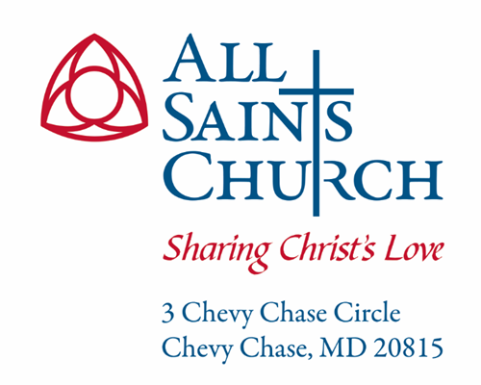

Vestry Meeting Minutes
December18, 2023

ATTENDANCE
x | Kevin Wrege-‘26  Senior Warden | x | Carrie Clark Carlson – ‘24 | x | Rev. BJ Buracker  Vicar
x | Dan Buckingham-‘26  Junior Warden | x | Liza Cole – ‘25 | x | Rev. Matthew Kozlowski  SeniorAssociate Rector
x | Michael Petrucelli – ‘24 | x | Catherine Eshelman – ‘25  Secretary | x | Lois McDonald  Chief of Staff
x | Mark Pelesh – ‘24  Treasurer | x | Susan Awad-‘24 |  | Teri Ballou  Communications Director
x | Beryl Scott-‘26 | x | Robert Roop – ‘25 | x | Rev. Jamie Pahl  Rector
x | Hugh Webster-‘26  Assistant Treasurer |  | Nick Thompson  Prager Metis
x | Jennifer Sirangelo-‘25 |  | Rev. Zacher Bayonne  Deacon
An x denotes that the individual was present, while an empty box denotes absence.

EXECUTIVE SUMMARY / ACTIONS AT A GLANCE
- A quorum was present  - Review and approval of minutes  - Treasurer’s report  - Rector’s report | - Reports from Clergy in attendance  - Old and new business  - Closing prayer and adjournment

DETAILS OF THE MEETING

Opening Father Jamie Pahl
Father Jamie opened the meeting in prayer at 6:07 pm.

Scriptural Reflection Kevin Wrege
Kevin offered a reflection on Advent, based on a reading from Fleming Rutledge.

Stewardship Liza Cole
Liza reported that the Stewardship Committee has to date raised 1.389K from 222 pledgers.
Pledges are coming in at a rate of 12-13 a week. We have 22 new pledges totaling $90K. The committee meets once more in January, and plans to offer three more testimonials before the conclusion of the campaign on January 15.
We invited the parish to contribute to a Christmas match fund again this year—an email blast with an invitation to give went out the week of December 11. It will be 50K match.
Liza reported that we have sent 402 letters to those who have not yet pledged, some to younger parishioners.
Finally, Liza reported that the Committee is considering publishing a list of every parishioner who has pledged. It was noted that some parishioners prefer to remain anonymous, so this would require confirming permission to list names. Amounts would not be disclosed.

Treasurer’s Report Mark Pelesh
Mark reported that the financial package was distributed the week before the meeting. He reported that revenue is up by over $300K versus the same time in 2022. Expenses are down by $24K vs this time last year. Deficits are also lower-$160K versus $486K last year. The Preschool surplus is $197K, down from $273K. Our investment accounts are up $408K versus a loss of $273K.
Mark noted that pledge fulfillment will be key to making our budget. At this point in time, there is $170K pledged that has not yet been paid. Pledge fulfillment plus the Christmas match will put us in a good position to make budget.

2024 Budget Lois McDonald
Lois reported on some of the shared priorities that were discussed at the Vestry and Staff retreats in November: a development director, a Wednesday evening meal , more social events, Alpha, and a more robust newcomer ministry.
Lois presented two budgets for discussion—one that plans for growth in the finances, and a no-growth option. The “growth” budget includes many of the priorities envisioned at the retreat, as well as some items that have been identified in the course of the last year. It proposes: buildings and grounds improvements, additional ministry support, an increased hospitality budget, additional funds for adult and childrens’ ministries, more funding for local and global outreach as well as Alpha and newcomer ministries, some salary increases and several new part time positions. It plans for increase in health insurance costs, and an increase to the Diocesan pledge.
The “no-growth” option plans for a modest increase in income from Women of All Saints and Kingdom Campaign Funds, and does not allow for any new initiatives, staff, discretionary building and grounds expenses, ministry, hospitality, newcomer, education or salary increases. Diocesan pledge stays at current level.
The Vestry discussed the budget options, noting that there will be opportunity for more conversation at the January meeting when we will have a better idea of what our pledge results are for 2024.

Presentation of Minutes Catherine Eshelman
The minutes of the November meeting were presented for approval. A draft of the minutes, as well as the attachments referenced in the minutes, were circulated in advance of the meeting. After a motion duly made and seconded, the Vestry voted to approve the following:
RESOLVED: That the minutes of the November 18, 2023 meeting are hereby approved, and the minutes placed on file along with the Parish records of the other meetings of the Vestry. These minutes shall be made publicly available.

Rector’s Report Father Jamie Pahl
Father Jamie reported that the head of the Mormon church on Western Avenue had reached out to request the use of All Saints meeting space early in the morning for youth meetings. The request has since been withdrawn as the Mormon church across from Columbia Country Club has offered space.
Father Jamie reported that his installation service will be held on March 9.

Senior Warden’s Report Kevin Wrege
No report

Junior Warden’s Report Dan Buckingham
Dan reported that the Buildings and Grounds committee will be meeting tomorrow night to take a look at three priorities: fire prevention, safety and security, and water leakage.

Report from Clergy in Attendance BJ Buracker
BJ reported that there will be four services on December 24 since Christmas Eve falls on a Sunday: 9:00. 3:00, 5:00 and 8:30.

Adjournment
There being no further business, the meeting was adjourned at 8:05 pm.

Action Items All
There are no action items currently.
No. | Action Items | Lead | Date Assigned | Target Date
1

