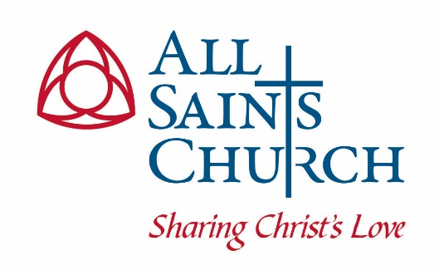
The Vestry of All Saints Church
Chevy Chase Parish
Agenda
Tuesday, April 18, 2023

- Prayer for Wisdom, Guidance, and Grace

- Scripture Reflection: Cynthia Bryant (10 minutes)

- Presentation of March Minutes: Chris Robinson, Clerk (5 minutes)

- The Treasurer’s Report for March: Mark Pelesh, Treasurer (10 minutes)
  - March Financial Reports: Nick Thompson, Prager Metis
  - Endowment Document Vote

- The Warden’s Reports
  - Susan Awad, Senior Warden (10 minutes)
    - Rector Search Update
  - Eric Fedowitz, Junior Warden (10 minutes)
    - Building & Grounds Update
    - Nominating Committee Report

- Reports of Clergy in Attendance (5 minutes each)
  - Update on Easter Attendance and Giving

- Reports of Clergy in Attendance (5 minutes each)

- Old Business (5 minutes)

- New Business (5 minutes)

- Closing Prayer and Adjournment

