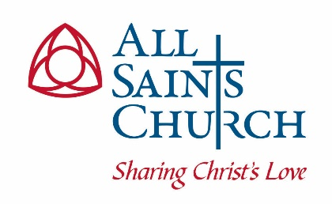
THE VESTRY OF ALL SAINTS CHURCH
CHEVY CHASE PARISH
AGENDA
Tuesday, January 18, 2022

- Prayer for Wisdom, Guidance and Grace

- Presentation of the Minutes of our December Meeting: Susan Awad, Vestry Clerk (5 minutes)

- The Treasurer’s Report: Michael Petrucelli, Treasurer (55 minutes)
  - Presentation of Financial Report
  - Annual Giving Campaign/Special Christmas Match
  - Approval of Clergy Housing Allowance Resolutions
  - 2022 Budget Discussion

- Rector’s Search: Tony D’Emidio, Sr. Warden (10 minutes)

- Annual Meeting Date – Lois McDonald, Parish Administrator (5 minutes)

- The Wardens’ Reports:
a. Tony D’Emidio, Senior Warden (5 minutes)
b. Eric Fedowitz, Jr. Warden (5 minutes)

- The Interim Rector’s Report: The Rev. Dr. William Buracker II (5 minutes)

- Reports from Clergy in Attendance (5 minutes each)

- Old Business

- New Business

- Closing Prayer and Adjournment

